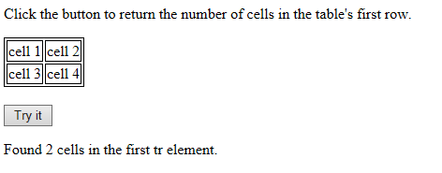

<!DOCTYPE html>

<html>

<head>

<style>

table, td {

border: 1px solid black;

}

</style>

</head>

<body>

<p>Click the button to return the number of cells in the table's first row.</p>

<table id="myTable">

<tr>

<td>cell 1</td>

<td>cell 2</td>

</tr>

<tr>

<td>cell 3</td>

<td>cell 4</td>

</tr>

</table>

<br>

<button onclick="myFunction()">Try it</button>

<p id="demo"></p>

<script>

function myFunction() {

var x = document.getElementById("myTable").rows[0].cells.length;

document.getElementById("demo").innerHTML = "Found " + x + " cells in the first tr element.";

}

</script>

</body>

</html>

Click the button to alert the innerHTML of the first cell (td element with index 0) in the table's first row.

<script>

function myFunction() {

alert(document.getElementById("myTable").rows[0].cells[0].innerHTML);

}

</script>

Click the button to change the content of the first table cell.

<script>

function myFunction() {

var x = document.getElementById("myTable").rows[0].cells;

x[0].innerHTML = "NEW CONTENT";

}

</script>

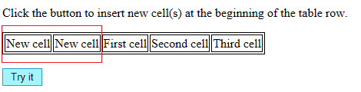

<!DOCTYPE html>

<html>

<head>

<style>

table, td {

border: 1px solid black;

}

</style>

</head>

<body>

<p>Click the button to insert new cell(s) at the beginning of the table row.</p>

<table>

<tr id="myRow">

<td>First cell</td>

<td>Second cell</td>

<td>Third cell</td>

</tr>

</table><br>

<button onclick="myFunction()">Try it</button>

<script>

function myFunction() {

var row = document.getElementById("myRow");

var x = row.insertCell(0);

x.innerHTML = "New cell";

}

</script>

</body>

</html>

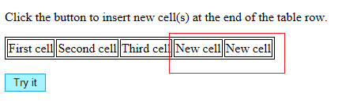

<!DOCTYPE html>

<html>

<head>

<style>

table, td {

border: 1px solid black;

}

</style>

</head>

<body>

<p>Click the button to insert new cell(s) at the end of the table row.</p>

<table>

<tr id="myRow">

<td>First cell</td>

<td>Second cell</td>

<td>Third cell</td>

</tr>

</table><br>

<button onclick="myFunction()">Try it</button>

<script>

function myFunction() {

var row = document.getElementById("myRow");

var x = row.insertCell(-1);

x.innerHTML = "New cell";

}

</script>

</body>

</html>

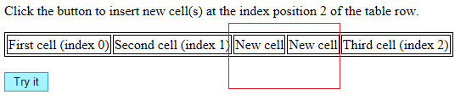

<!DOCTYPE html>

<html>

<head>

<style>

table, td {

border: 1px solid black;

}

</style>

</head>

<body>

<p>Click the button to insert new cell(s) at the index position 2 of the table row.</p>

<table>

<tr id="myRow">

<td>First cell (index 0)</td>

<td>Second cell (index 1)</td>

<td>Third cell (index 2)</td>

</tr>

</table><br>

<button onclick="myFunction()">Try it</button>

<script>

function myFunction() {

var row = document.getElementById("myRow");

var x = row.insertCell(2);

x.innerHTML = "New cell";

}

</script>

</body>

</html>

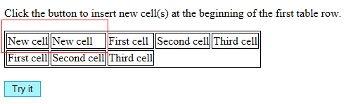

<!DOCTYPE html>

<html>

<head>

<style>

table, td {

border: 1px solid black;

}

</style>

</head>

<body>

<p>Click the button to insert new cell(s) at the beginning of the first table row.</p>

<table id="myTable">

<tr>

<td>First cell</td>

<td>Second cell</td>

<td>Third cell</td>

</tr>

<tr>

<td>First cell</td>

<td>Second cell</td>

<td>Third cell</td>

</tr>

</table><br>

<button onclick="myFunction()">Try it</button>

<script>

function myFunction() {

var firstRow = document.getElementById("myTable").rows[0];

var x = firstRow.insertCell(0);

x.innerHTML = "New cell";

}

</script>

</body>

</html>

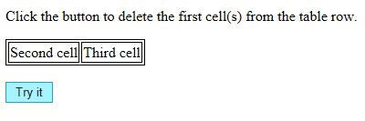

<!DOCTYPE html>

<html>

<head>

<style>

table, td {

border: 1px solid black;

}

</style>

</head>

<body>

<p>Click the button to delete the first cell(s) from the table row.</p>

<table>

<tr id="myRow">

<td>First cell</td>

<td>Second cell</td>

<td>Third cell</td>

</tr>

</table><br>

<button onclick="myFunction()">Try it</button>

<script>

function myFunction() {

var row = document.getElementById("myRow");

row.deleteCell(0);

}

</script>

</body>

</html>

var rows = document.getElementById('Just_for_california');

for (var j = 0; j < rows.length; j++) {

rows[j].deleteCell(7);

}

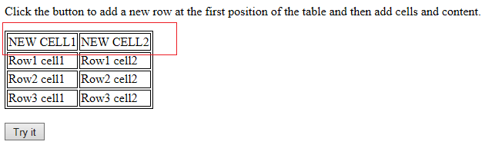

<!DOCTYPE html>

<html>

<head>

<style>

table, td {

border: 1px solid black;

}

</style>

</head>

<body>

<p>Click the button to add a new row at the first position of the table and then add cells and content.</p>

<table id="myTable">

<tr>

<td>Row1 cell1</td>

<td>Row1 cell2</td>

</tr>

<tr>

<td>Row2 cell1</td>

<td>Row2 cell2</td>

</tr>

<tr>

<td>Row3 cell1</td>

<td>Row3 cell2</td>

</tr>

</table>

<br>

<button onclick="myFunction()">Try it</button>

<script>

function myFunction() {

var table = document.getElementById("myTable");

var row = table.insertRow(0);

var cell1 = row.insertCell(0);

var cell2 = row.insertCell(1);

cell1.innerHTML = "NEW CELL1";

cell2.innerHTML = "NEW CELL2";

}

</script>

</body>

</html>

<http://demo.mysamplecode.com/JavaScript/pages/javaScriptDynamicTable.jsp>

<http://forums.devshed.com/javascript-development-115/dynamically-create-button-cell-based-tablerow-id-635799.html>